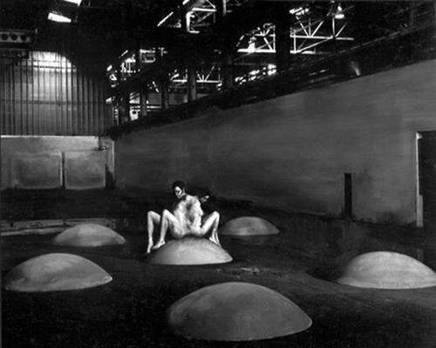
Couple (© Frank Garvey)

For immediate release
Thurs., April 19, 2007

Press contact:
Frank Garvey
fgarvey@omnicircus.com
415-701-0686

OmniCircus Screens new SOCIAL SURREALIST 'wall of ashes' film and installation WITH ROBOTS, SCULPTURES, PAINTINGS & MUSIC

Boundary-crossing, poetic film and installation elegiacally juxtapose déjà vu with human suffering in mythic, timeless Chicago urban setting.
SAN FRANCISCO, Calif.—OmniCircus is proud to present founder Frank Garvey's
new feature film and installation entitled "Wall of Ashes," Saturday, May 5, 2007 at the SoMa theatre-gallery, located at 550 Natoma St. The event starts promptly at 7:30 p.m. with the director introducing his robots, paintings and sculptures and opening the film program with several shorts. The feature will be followed by an after-party with the writer-director and several members of the cast. A tax-deductible sliding scale donation of $5-$10 is suggested. No one will be turned away for lack of funds.
'Wall of Ashes' is Garvey's hallucinatory musico-drama about a bus driver, played by Jim Burkhart, who journeys through hell tormented by memories of a lost life. Along the way, he collides with nightmarish visions of sword-fighting robots, a beautiful stripper turned junkie, an armless transgender artist who paints amazing canvasses with her feet, surreal sack-people and other misfits. All the while, he experiences a powerful recurring vision of a transcendentally beautiful singer-wraith, played by the heart-rending vocalist-actress Vivian Davis in what might be the most enigmatic performance of a lifetime. The action takes place in a grainy, industrial landscape of filthy streets, dope-infested flop hotels and abandoned warehouses...in other words, working-class Chicago.
Several years in the making, the film is familiar and strange at the same time, a fulminating, meta-realistic soup of Garvey's schizoid inner visions. 'Wall of Ashes' vividly illuminates a saturnine backdrop threaded with the deformities of modern times.
The 'Wall of Ashes' cast includes Ted Levine ("Silence of the Lambs,'""Monk"); Jack Wallace ("Death Wish," "The Bear"); Warren Leming, Ric Peake, Vivian Davis, Tony Lincoln, Simone,
Lorenza Bottner, Lee Groban and Tom Erhart.
'Wall of Ashes' includes an eponymous installation which integrates Garvey's multimedia talents
-more-
in video, paintings, sculptures, life-sized performing robots, 3-D computer animation and virtual puppetry. Taking more than 15 years to create, 'Wall of Ashes' was designed to be shown within this womb-like environment, a kind of Sistine Chapel for the dispossessed

Preview it here: http://www.omnicircus.com
About OmniCircus Productions
Founded in 1988 by artist-composer Frank Garvey, San Francisco's OmniCircus Productions runs one of the world's premier performance and gallery spaces for experimental, surrealist cabaret, robotic art, music and multimedia. OmniCircus is also renowned for its resident performance group, consisting of a dedicated and superbly borderline-functional ensemble of actors, dancers, musicians and the incredible Junkyard Cabaret and Robotic Ensemble, a robotic red light district of life-sized mechanical beggars, hookers, junkies and street preachers. OmniCircus' electrifying live shows established their notoriety with scorching depictions of a pre-apocalyptic American ghetto holocaust -- combining avant-fusion musicianship, virtuosic vocalists, en-sacked performance artists with life-sized robotics, 3-D animation and midi-controlled virtual-reality (VRpit) puppets.
For more information, or to purchase advance tickets, call 415.701-0686 or email fgarvey@omnicircus.com or go to www.omnicircus.com. Seating is limited. OmniCircus is a 501(c)3 nonprofit. All donations are tax-deductible to the fullest extent allowed by law.

###

