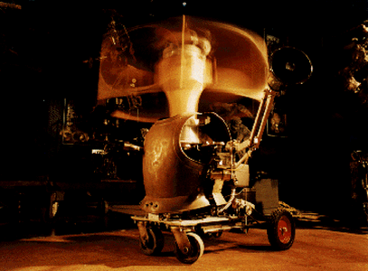
Godfella by Frank Garvey

For immediate release

OMNICIRCUS' FRANK GARVEY ROBOT + SCULPTURE IN FIRST ANNUAL BAY AREA SCULPTURE SHOW AT VARNISH FINE ART GALLERY

Free opening reception Sat., Aug. 21, 7-11 p.m.

Fellini-esque junkyard robots and sculpture reminiscent of Rodin, Henry Moore, open window to America 's forgotten in war, prison, ghetto

WEDNESDAY, AUGUST 18, 2004, San Francisco, Calif. -- The work of noted social surrealist artist-composer Frank Garvey, founder of OmniCircus, is part of the first annual Bay Area sculpture show at Varnish Fine Art. A free opening artist's reception will be held on Sat., Aug. 21, from 7-11 p.m. at the gallery, located at 77 Natoma St., San Francisco, Calif., 94105. The show runs through Sept. 18.

The robot called "Godfella" is one of a series of archetypes created by the artist to call attention to society's lost and forgotten ghetto denizens, including street preachers, prostitutes, drug addicts and homeless, crippled beggars. It features the artist's characteristic construction style, combining parts from rusty farm tools and junkyards with bleeding edge robotics technology.

For more information or to arrange an interview with the artist, please contact Lori Higa at 415-626-4959, email lhiga@pagecage.com or Frank Garvey at 415-701-0686, email fgarvey@omnicircus.com or see the OmniCircus web site at www.omnicircus.com.

ABOUT OMNICIRCUS
OmniCircus is a 501(3)(c) nonprofit organization dedicated to, and providing a forum for experimental art of the working class, fostering expression of the urgent, revolutionary and profound need for social, political and economic change.

Headquartered in San Francisco's SoMa district, OmniCircus is the premier San Francisco center for avant cabaret and robotic art, music and multimedia. The OmniCircus Junkyard Cabaret and Robot Ensemble is a surrealist cabaret founded in 1988 by composer-artist Frank Garvey. OmniCircus shows integrate live heavy-mental, world-confusion, neo-crassical science-friction music with dancers, actors, life-sized performing robots and midi-controlled virtual-reality puppets.

OmniCircus is between 6th & 7th & Mission & Howard, on the corner of Russ & Natoma Sts. in SoMa. The door is on Russ St.

The OmniCircus performance space has a permanent installation of paintings, sculpture, animation and robotics, available for viewing most Saturdays, 12 noon-4 p.m. and by appointment.

####

