FOR IMMEDIATE RELEASE
Monday, Mar. 6, 2006

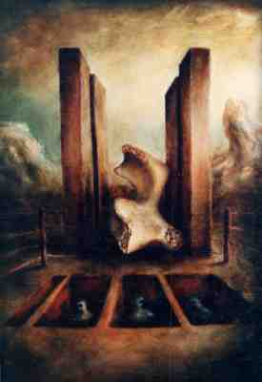

The Disappeared – oil painting by Frank Garvey

MUDDY WATERS CAFE SERVES UP HOT JAVA WITH UNDERGROUND, SOCIAL SURREALIST ART OF FRANK GARVEY

Free opening reception on Fri., Mar. 10 from 7-11 p.m. features live music

SAN FRANCISCO, Calif. -- A hyper-caffeinated brew of jack-in-the-boxes from hell, vaginal orchids, armless but not harmless alien bone-beings and espresso will be served at the opening of Frank Garvey's exhibit of paintings and sketches at Muddy Waters cafe, on Fri., Mar. 10 from
7-11 p.m. The cafe is located at 1304 Valencia near 24th St., phone 415-647-7994.

Garvey's paintings ferment Da Vinci-like technique into audacious, oracular visions of working class oppression, backlit by the atomic pollution of deadly mushroom clouds. Miniature tableaux, packed tight with sardine tin precision, cast humankind's inhumanity to man in blinding relief, from mohawked skateboarders to jiving carnival freaks. The founder of SoMa's OmniCircus, Garvey's 15-year-old theatre is ground zero for grim, post-9/11 Guignol movie sets, prophesizing America's soul-destroying demise. A science-friction, neo-crassical cabaret of junkyard robots, Garvey's OmniCircus exposes the brutal and violent collisions of uber-geopolitics with human suffering in a ballistic ballet of butoh, live music, theatrics, virtual puppetry, experimental digital video and searing performance art.

For more information, contact Lori Higa at 415-626-4959, lorihiga@gmail.com or Frank Garvey at Omnicircus, 415-701-0686, fgarvey@omnicircus.com, www.omnicircus.com.

###

