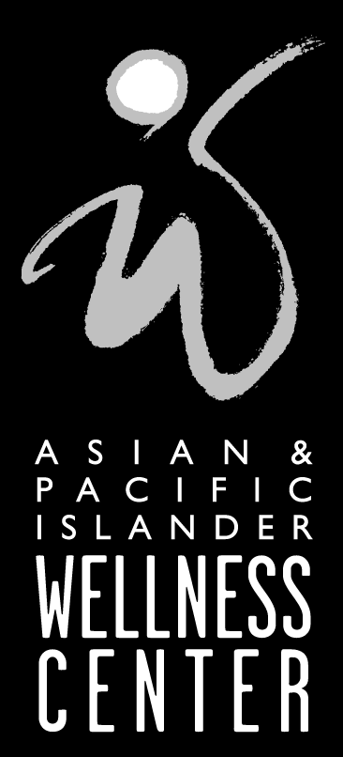
FACT SHEET

HIV/AIDS and Asians & Pacific Islanders in San Francisco

Nationally, HIV/AIDS continues to spread in communities of color, including Asians and Pacific Islanders (A&PI). In the third decade of the epidemic, San Francisco remains one of the epicenters of the A&PI HIV/AIDS epidemic.

- 10 per cent of A&PI men who have sex with men (MSM) tested positive for HIV by blood tests in 2004, which was conducted as part of a behavioral surveillance survey of San Francisco MSM (Raymond 2005). When asked for their HIV status, only 6.1 per cent of the A&PI MSM knew and/or reported that they were HIV+.

- From 2000 to 2004, the HIV infection prevalence rate rose from 2.6 per cent to 3.8 per cent among A&PIs 18-29 years old in San Francisco, according to preliminary analysis (Raymond 2005).
The cumulative number of A&PI AIDS cases
in San Francisco is 785 as of Mar. 31, 2005:

By gender: Male (89 per cent), female (7 percent), and transgender (4 per cent)
By transmission: Gay/bisexual men (77.8 percent), gay/bisexual/intravenous drug users (IDU) (7.3 per cent), lesbian/bisexual IDU (0.3 per cent), IDU not gay/bi men (5.0 per cent), hemophiliac transfusion recipient (2.9 per cent), heterosexual (3.4 percent)
By age: 14.5 per cent are 13-29 years old, 44.3 per cent are 30-39 years old
By A&PI ethnicity: Filipinos (33 per cent), Chinese (23 per cent), Japanese (12 per cent), Pacific Islander (8 per cent), Southeast Asian (9 per cent), Korean (2 per cent), and “other” (13 per cent)

- San Francisco’s A&PI AIDS incidence rate is the nation’s highest, at more than six times the national A&PI AIDS rate, making San Francisco an epicenter of the HIV/AIDS epidemic for A&PIs (Wortley et al. 2000). Nationally, according to the Centers for Disease Control and Prevention, the number of AIDS diagnoses increased among A&PIs by 34 per cent from 1999 to 2003.

- In a 2002 community study conducted by A&PI Wellness Center in collaboration with UCSF Center for AIDS Prevention Studies, alarming baseline findings for the A&PI MSM in the study showed that with their regular partner:

  - 70 per cent engaged in unprotected insertive anal intercourse (UIAI)
  - 56 per cent engaged in unprotected receptive anal intercourse (URAI)
  - 40 per cent never/almost never discussed safe sex or condom use

- 30 per cent of A&PI MSM reported having URAI in the three months prior to a 2003 survey conducted in Boston, Chicago, Los Angeles, Honolulu, New York and San Francisco (A&PI Wellness Center 2004).

- From 2000 to 2002, the URAI rate increased by 9.6 per cent for A&PIs in California. Whites had the second highest increase, 6.3 per cent (UARP 2004).

-more-

REFERENCES

Asian & Pacific Islander Wellness Center in collaboration with five other A&PI AIDS service organizations: 2004. “National A&PI MSM Knowledge, Attitudes, Beliefs, and Behaviors, 2003.”

Osmond, D.H., Page, K., Wiley, J., Garrett, K., Sheppard, H.W., Moss, A.R., Schrager, L., and Winkelstein, W.: 1994. ”HIV infection in homosexual and bisexual men 18 to 29 years of age: the San Francisco Young Men's Health Study.” American Journal of Public Health 84: 1993-1997.

Raymond, H.: 2005. Telephone communication.

San Francisco Dept. of Public Health: 2005. “Quarterly AIDS Surveillance Report AIDS Cases Reported through March 2005.”

University-wide AIDS Research Program (UARP) and the HIV Prevention Research and Evaluation Section: 2004. “Report on race/ethnicity: California HIV prevention indicators.”

Wortley, P.M., Metler, R.P., Hu, D.J. and Fleming, P.L.: 2000. “AIDS among Asian and Pacific Islanders in the United States.” American Journal of Preventive Medicine 18(3): 208-214.

###

